**CHARITON FREE PUBLIC LIBRARY VIDEO SURVEILLANCE POLICY**

**Approved April 14, 2022**

**(Approved July 14, 2016)**

The Chariton Free Public Library strives to maintain a safe and secure environment for its staff and patrons. In pursuit of this objective, selected public areas of the library premises are under continuous video surveillance and recording. This policy is in force to deter public endangerment, vandalism, theft and mischief in unsupervised areas and to identify those individuals involved in such activity for law enforcement purposes, while adhering to the applicable federal, state, and local law concerning the confidentiality of library records, the disclosure of public records, and the protection of individual privacy. The government does not have the right to know how people are using their libraries unless there are legitimate, cogent and compelling reasons and pursuant to a court order.

The Library Director (NOT the Board of Trustees) is the legal custodian of this information and has the sole discretion to release it to law enforcement pursuant to court order. While courts allow video surveillance in public libraries, the security tapes are considered confidential records of the Library and require a court order to view.

The Library will post signage at the library entrance at all times and in other appropriate locations. See attachment.

Cameras may be installed in locations where staff and customers would not have an expectation of privacy. Examples include common areas of the Library (entrances, near book and media collections, public seating, and parking areas). Cameras will not be installed in areas where staff and public have a reasonable expectation of privacy, such as restrooms, nor are they positioned to identify a person’s reading, viewing or listening activities in the library.

No monitoring shall be done on the basis of race, color, religion, sex, age, national origin, veteran status, disability that can be reasonably accommodated, or any other basis prohibited by federal, state, or local law.

The system will be secure and may only be accessed by Library Staff. The Library Staff, in the course of their normal duties will monitor and operate the video security system. Only Library Staff are authorized to access the recorded archival data in pursuit of incidents of criminal activity, litigation, or violation of the Library Conduct Policy as related to a specific incident.  Such persons shall not violate any laws relevant to this policy in performing their duties and functions related to the video security system.  Software for monitoring cameras and recorders shall be installed only on computers under the direct control of staff members.

**Use/Disclosure of Video Records**

Images from the video security system are stored digitally on hardware in the Library. Security camera footage will be kept confidential. Recordings are kept in accordance with the Library’s approved records retention schedule, unless required as part of an ongoing investigation or litigation. In the event of a search warrant, the Library Director will comply with the search warrant and consult with legal counsel. NOTE: Search warrants are confidential until filed with the court. Upon receipt of a subpoena or other court order, the Library Director shall consult with legal counsel.

A breach of this Policy may result in disciplinary action up to and including dismissal. Any library employee who becomes aware of any unauthorized disclosure of a video record and/or a potential privacy breach has a responsibility to ensure that the Director is immediately informed of the breach.

If a privacy breach has occurred (loss, theft, or inadvertent disclosure of personal information) immediate action will be taken to control the situation, (e.g. determine if unauthorized access to an electronic system has occurred, retrieve copies of recorded information, and investigate & resolve security issues). The objectives of investigation should include a review of the circumstances surrounding the event as well as the adequacy of existing policies, procedures and technology for protecting personal information. The Director will notify individuals whose personal information has been disclosed and try to resolve a complainant’s concerns informally at the onset of the complaint.

**Attachment. Signage**

Common wording is: “Areas of the building are under video surveillance. Images may be collected that allow an individual to be identified. The use of video surveillance is solely for the purposes of controlling theft, ensuring the safety of library users and staff, and facilitating the identification of individuals who behave in a disruptive manner, cause damage to library property or are otherwise acting in conflict with the Library’s Rules of Conduct.”

When an employee witnesses an event or receives information that may cause him/her to believe that a situation exists that requires investigation, the following procedure shall be followed:

1. The employee shall complete an incident report and request that the recordings be reviewed or that the behavior be monitored as it occurs.
2. If the Director approves the monitoring, she and the employee shall attempt to locate the necessary recorded or live data.
3. If the recording and/or monitoring provides sufficient proof of malfeasance, the Director may approve disciplinary or other corrective action, and may share the evidence with law enforcement agencies.

**Imminent Danger**

When there is a credible likelihood of imminent danger to persons or property, any staff member may request to use the surveillance system as needed to thwart or document any such action.

When an incident occurs on Library premises:

* Video image recordings will be used to identify the person or persons responsible for Library policy violations, criminal activity, or actions considered disruptive to normal Library operations.
* Video records may be used to assist law enforcement agencies in accordance with applicable state and federal laws.
* Video recordings of incidents can be retained and reviewed as long as considered necessary by the Library Director.
* Images may be shared with other Library staff to identify person(s) suspended from Library property and to maintain a safe and secure environment.
* 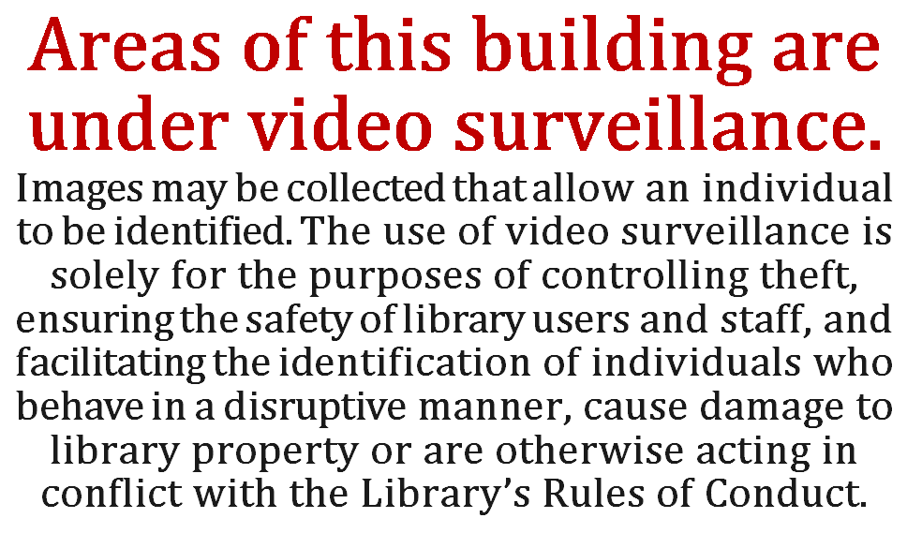While it is recognized that video surveillance will not prevent all incidents, its potential deterrent effect and resource as a means of identifying and prosecuting offenders is considered worthwhile.