CHARITON PUBLIC LIBRARY
CIRCULATION POLICY
(Approved 3/12/26)
(4/13/2023)

Patron Eligibility and Responsibilities
The Library has no residency requirements to apply for a Library card. Applicants need only provide their actual physical residence and a mailing address, if different from the residential address.
Persons under the age of 16 must have a parent or guardian sign their registration.
Library privileges may be suspended or revoked if overdue items are not returned, or damage or replacement costs are not paid, or if the patron violates any part of the Library Conduct Policy.

Some electronic services, such as BRIDGES downloadable e-content and Online Databases are provided by vendors who enforce restrictions within their contract, allowing only residents of the Library’s legal service area to access their content. The Library’s legal service area is determined by tax funding and includes residents of the Cities of Chariton, Derby, Lucas, Russell and Williamson, and the residents of the rural areas of Lucas County. The Library will abide by its contract with such vendors, and cardholders who live outside of the legal service area will not have access to these services.

Patrons are responsible for all transactions committed with their card. It is strongly recommended that a patron not lend his/her card to others as the patron will be held responsible for any fees accrued on the card. The Parent or Guardian is responsible for all transactions committed by a minor, or with that minor’s card. Patrons shall give immediate notice of a lost Library card.

Patrons must present their library card or a picture ID to conduct any transaction. Patrons are responsible for returning borrowed materials or equipment to the Library, clean and in good condition, on or before the date due.

Patrons shall report any damage to materials or equipment to the Library staff. Patrons are responsible for prompt payment of damage costs for materials or equipment, and assessments for lost items.

Registration for Library Card (Registration Form Attached)
Library cards are issued for three years, and are renewable upon expiration. Cardholders must notify the Library if their name, address telephone number or email address changes from that listed in their record.

Applications: Patrons must apply for a Library card in person and present picture identification. Acceptable forms of identification are a State ID, Driver’s License, Student ID, Military ID or Passport.

Charger Library Card Applications: PreK-12th Grade students attending any Chariton educational facility may acquire a Library card via a Charger Library Card Registration form. A parent/guardian does not need to be present in the Library to sign the form. Forms are available to school staff to send home with the student to acquire the required parent/guardian’s signature. No picture ID is required. Forms must be submitted to the Library by staff of the educational facility. Students may use their student ID card as picture ID for checkout.

Registration includes full name, birthdate, home address, telephone number and email address. PO Box addresses may be added to the account for mailing purposes, but a patron’s home address must be provided to demonstrate actual location of taxpayer residence. Patrons shall read the Patron Responsibility and Waiver of Confidentiality Agreement when registering for a Library card. Signing the patron registration (attached) indicates compliance with the conditions of this Agreement.

Lost Card
A patron who reports a lost card may re-register at the circulation desk. Picture identification is required. There is a $1 fee for the first replacement card, a $5 fee for the second, and a $10 fee for each subsequent replacement card. A permanent record of each replacement will be placed in the patron’s account. Once a card number is replaced, the original number can no longer be used in the Library’s system & if the card is located, it should be destroyed.

Borrowing Limits & Loan Periods
Patrons may check out unlimited Books for a three-week period, with an option to renew once.
Patrons may check out unlimited Audiobooks for a three-week period, with an option to renew once.
Patrons may check out five (5) Videos per card for seven (7) days. Videos are non-renewable.

Renewals
Borrowed items may be renewed in person, by telephone, or online for one additional loan period, with the exception of Videos or other one-week items.
The Librarian has discretion to make exceptions to renewal on high demand items or items on reserve.
Extended loans cannot be renewed.
Items which have holds pending cannot be renewed.
Items eligible for renewal will be renewed automatically.

Extensions & Educational Loans
Items may be checked out, upon request, for a 6-week period to accommodate vacations, illness or other patron needs. The extended checkout time will include the one available renewal.

Items borrowed for use in an educational setting; a classroom, daycare or home-schooling situation, may be checked out for an extended period to meet the needs of a given project. A teacher or other education professional may request an extension at the time of checkout. A student must present documentation in the form of a course syllabus or assignment sheet. Extensions are at the discretion of the Librarian, and may not be granted on high-demand materials. The individual borrowing the items is responsible for their return and any fees which accrue.

Holds
Patrons may place holds on items through the Librarian at the circulation desk. A hold can only be placed on an item which is currently checked-out or otherwise unavailable. “Pending” holds remain in the system for 60 days. Once a “pending” hold becomes “ready”, patrons will be notified by phone and will have 5 business days following the day of notification to pick up the item before it passes on to the next patron or is returned to the shelf.

Interlibrary Loans
The Chariton Public Library participates in Interlibrary Loan Programs sponsored by the State Library of Iowa. The Library will request materials for patrons from other Iowa libraries if the material is not in our collection. Patrons must have a current library card and no outstanding assessments to be eligible for this service. Materials copyrighted in the past year are generally not available through this service. A one-month lending period shall apply unless the lending library states otherwise. The Chariton Public Library will lend its materials to other libraries when such a request is received.
In addition, as part of the statewide Open Access program, Chariton Public Library patrons may acquire borrower cards at other Iowa Libraries and check out materials at those Libraries. Those materials can then be returned to the Chariton Public Library and will be returned to the lending Library at no cost to the patron.

Audio-Visual Equipment Loans
Patrons must be 16 years old and have a current library card to borrow Library equipment. At the time the equipment is borrowed, the patron shall sign a contract claiming all responsibility for the equipment until it is returned. Equipment must be returned, in person, to the Librarian, by the patron who signed the contract. All issues and damages are to be reported to the Librarian, who will set a damage or replacement fee, if applicable. A variety of projectors and screens are available for checkout. Patrons may consult the Librarian for specifics. All equipment loans are at the discretion of the Librarian.

Overdues
Library Patrons with overdue items shall have borrowing privileges suspended until all items on the card are returned.

Damaged, Lost or Stolen Items
Patrons are responsible for returning borrowed materials in good condition and may be assessed costs for damaged or lost items. Unreturned items more than two months overdue will be considered lost or stolen and replacement costs will be assessed. (Iowa Codes 702.22, 808.12, and 714.5)
Library privileges will be suspended or revoked if damage or replacement assessments are not paid. Legal action may be taken by the Library upon failure to return items or pay the costs assessed.

Assessments will include the actual replacement and processing costs. “Avoidable damage” to the cases housing audiovisual items, such as the heat-warping that occurs when the item is left in the sun or near a heat source, will also be assessed to the patron in addition to payment for any damage sustained by the parts inside the case.

Amounts are assessed per item and determined by the Library Director, using current availability and pricing as listed by product providers, with replacement costs for individual parts of audiovisual items determined by the source of purchase or replacement.

All payments made to the Library are non-refundable.

Claim of Return
Patrons may make a Claim of Return if they believe that an item still checked-out on their card has been returned. Staff will check to ascertain if the item has actually been misplaced within the Library, while the item itself remains checked-out on the patron’s card. If the item is located in the Library, it will be removed from the patron’s record with no fees assessed.

If the item is not found in the Library after two months, the item will be converted to a “lost item” in the Library’s system, pending further action. Patrons must return the item if they locate it, or pay the replacement price.

CHARITON PUBLIC LIBRARY CLAIM OF RETURN Due Date: ____________ Return Date: ______________ Date & Staff Initials ________

Library Cardholder Name: ____________________________________ Phone Number: _______________________ Card Number: _________
If cardholder is a minor Parent/Guardian Information: ____________________________________________ Card Number: _________

Title: ________________________________ Author: _________________________ Call Number: _____________________ Barcode:___________

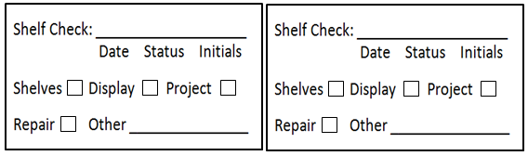

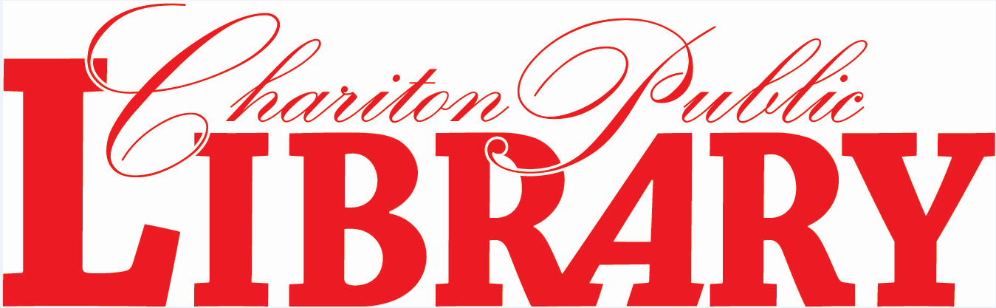
LIBRARY CARD REGISTRATION APPLICATION
Picture Identification Required, Please Print
______________________________________________________________ CARD # _______________
Print Full Name Last, First Middle Initial.

Patron Responsibility

I understand and agree that this registration application constitutes a legally-binding contract between the Library and myself which obligates me to:

- comply with all rules and policies of the Chariton Free Public Library as from time to time amended.
- personal responsibility for all materials borrowed on this card and their timely return.
- personal responsibility for all penalties and/or financial charges accrued on this card.
- notifying the Library immediately if my card is lost or stolen to prevent use by another person for which I will be held accountable.
- personal responsibility for any transactions committed if I have allowed anyone else use of this card.
- notifying the Library if I have a change of home address, phone number or email address.

Waiver of Confidentiality Agreement

I agree to waive confidentiality requirements as determined by Iowa Code Sec. 22.7(13) :
Iowa Code Sec. 22.7(13) (Confidential Records)
22.7 The following public records shall be kept confidential, unless otherwise ordered by a court, by the lawful custodian of the records, or by another person duly authorized to release such information:
13. The records of a library which, by themselves or when examined with other public records, would reveal the identity of the library patron checking out or requesting an item or information from the library. The records shall be released to a criminal or juvenile justice agency only pursuant to an investigation of a particular person or organization suspected of committing a known crime. The records shall be released only upon a judicial determination that a rational connection exists between the requested release of information and a legitimate end and that the need for the information is cogent and compelling.

Applicant Signature________________________________________ Date ___________________

If under 16, Guardian Signature_________________________________ Date ___________________

Guardian Name____________________________________________ Guardian Card # __________

Library Staff will assign a card number and your student’s card will be delivered to their classroom teacher.
Fill out
both sides completely.
Make sure it’s legible.
CHARGER LIBRARY CARD REGISTRATION
______________________________________________________________ CARD # _______________
Print Child’s Full Name Last, First Middle Initial.

Patron Responsibility

I understand and agree that this registration application constitutes a legally-binding contract between the Library and myself which obligates me to:

- comply with all rules and policies of the Chariton Free Public Library as from time to time amended.
- personal responsibility for all materials borrowed on this card and their timely return.
- personal responsibility for all penalties and/or financial charges accrued on this card.
- notifying the Library immediately if my card is lost or stolen to prevent use by another person for which I will be held accountable.
- personal responsibility for any transactions committed if I have allowed anyone else use of this card.
- notifying the Library if I have a change of home address, phone number or email address.

Waiver of Confidentiality Agreement

I agree to waive confidentiality requirements as determined by Iowa Code Sec. 22.7(13) :
Iowa Code Sec. 22.7(13) (Confidential Records)
22.7 The following public records shall be kept confidential, unless otherwise ordered by a court, by the lawful custodian of the records, or by another person duly authorized to release such information:
13. The records of a library which, by themselves or when examined with other public records, would reveal the identity of the library patron checking out or requesting an item or information from the library. The records shall be released to a criminal or juvenile justice agency only pursuant to an investigation of a particular person or organization suspected of committing a known crime. The records shall be released only upon a judicial determination that a rational connection exists between the requested release of information and a legitimate end and that the need for the information is cogent and compelling.

Guardian Signature______________________________________________ Date ___________________

Guardian Name (printed) ________________________________________ Guardian Card # __________

My Child’s Information: Current Classroom Teacher ___________________________________

Birthdate ______________________ /_______________ /_________________

Gender Female Male Prefer not to respond

email(s) __________________________________________________________________________________________________________
Phone Number(s) ____________________________________________________________________________________________
Address ____________________________________________________________________________________
City ____________________________________ State ____________ Zip Code ___________________
My child lives
In Chariton city limits
In Derby city limits
In Lucas city limits
In Russell city limits
In Williamson city limits
In the Rural area of Lucas County
Outside of Lucas County
Parent Names: (Print) _______________________________________ _______________________________________
_______________________________________ _______________________________________

